

Compositor
API Reference
© 2018 All rights reserved by Metrological
This document contains information which is proprietary and confidential to Metrological. It is provided with the expressed understanding that the recipient will not divulge its content to other parties or otherwise misappropriate the information contained herein. This information is furnished for guidance; specifications and availability of goods mentioned in it are subject to change without notice. No part of this publication may be reproduced, stored in a database, retrieval system or transmitted, in any form or by any means, electronic, mechanical, photocopying, recording or otherwise, without the written prior permission of Metrological.

History
Version | Date | Author | Description
0.1 | 10-07-2018 | C.Custers | Initial version.
0.2 | 24-09-2018 | C.Custers | Update after refactoring
0.3 | 08-09-2018 | C.Custers | Add Zorder and Below-methods+reordering method
0.4 | 09-09-2018 | C.Custers | Reorder introduction and configuration
0.5 | 12-10-2018 | C.Custers | Update References + Adjust layout

Table of Contents
1. Introduction 4
1.1 Scope 4
1.2 Case sensitivity 4
1.3 Acronyms, Abbreviations and Terms 4
1.4 Standards 4
1.5 References 5
1.6 Open Issues 5
1.7 Limitations 5
2. Compositor Plugin 6
2.1 Introduction 6
2.2 Configuration of Compositor 6
2.3 Application Programming Interface (API) 7
2.3.1 General information 7
2.3.2 Get Clients in ZOrder 7
2.3.3 Get Client Geometry 7
2.3.4 Get Screen Resolution 8
2.3.5 Adjust Screen Resolution 8
2.3.6 Switch Client to Top 8
2.3.7 Place ClientA below another ClientB 9
2.3.8 Switch Input to <client> 9
2.3.9 Adjust Opacity 9
2.3.10 Adjust Visibility 10
2.3.11 Adjust Geometry 10
2.3.12 Kill <client> 10

Introduction

Scope
This document describes the Plugin Compositor API interface. This plugin can be configured to be loaded and executed in the WPEFramework and offers user input functionality on the platform. For details on the WPEFramework API, refer to: [WPEF].

Case sensitivity
All identifiers on the interface described here are case-sensitive. e.g. an id known in the plugin as 'C0FFEE' is not the same as 'c0ffee'.
All keywords, entities, properties, relations and actions should be treated as case-sensitive.

Acronyms, Abbreviations and Terms
The next list provides an overview of acronyms and abbreviations used in this document and their definitions.
Acronym | Definitions
API | Application Programming Interface
JSON | JavaScript Object Notation
UTC | Coordinated Universal Time

Below terms are listed with their definitions, as used in this document.
Term | Definitions
Callsign | The callsign is the name given to an instance of a plugin. One plugin can be instantiated multiple times, but each instance the instance name, callsign, must be unique.
Proxy | An object in one process space representing the “real” object in another process space. The Proxy takes care of marshalling the parameters.
Stub | An object in the process space that contains the actual object. The stub takes care of un-marshalling the request from the Proxy and executes the call, on behave of the Proxy object, on the real object

Standards
Date time formats between the systems shall be in UTC time and W3C ([ISO-8601] profile) formatting [ISO-8601], e.g.: 2004-11-05T13:15:30Z. This way time discontinuities can be avoided due to daylight savings. Note that all interfacing systems must decode/encode the date time to the correct local time.
Languages used in the WPEFramework will be conform [ISO-639-2] using two letter language codes. If WPEFramework encounters a language code it does not recognize, it will use ‘xx’ instead. For a list of available two letter ISO language codes, please visit: [ISO-639-2].

References

[WPEF] | WPEFramework API Reference
[HTTP] | Hypertext Transfer Protocol
[ISO-8601] | Date and time format
[ISO-3166] | Country code specification
[ISO-639-2] | Language code specification (Alpha-2 code)
[JSON] | JavaScript Object Notation
[URLENC] | URL Encoding

Open Issues
This is a list of open issues that needs to be resolved:
- This document is still a work in progress.

Limitations
The information described in this document is preliminary and subject to change in the future.
Legend:


Be aware of: implementation choice is needed or side-effect needs to be handled.


Implementation advice: Guide line for implementation mostly related to performance.

Compositor Plugin

Introduction

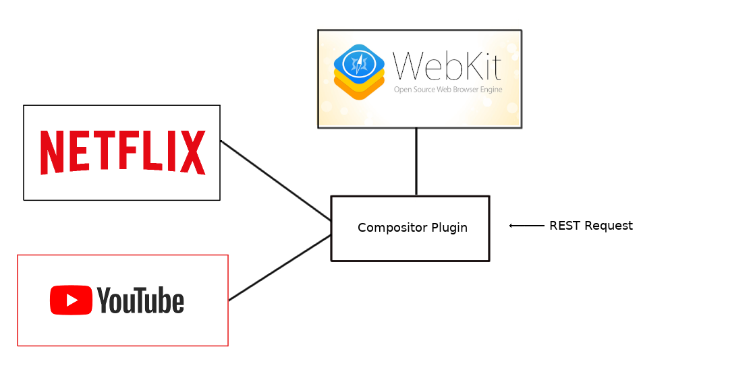

In the illustration above one is able to see the overall working of the Compositor-plugin. One can distinguish the three clients: WebKitBrowser, Netflix and Youtube and the Compositor-plugin.
Whenever a REST- request is send to the plugin. The plugin will then handle the request for the compositor-server. So, basically the Compositor-plugin tasks can be subdivided into three main tasks:

1) It acts as REST-service that handles all requests it receives from its compositor-clients.
2) It contains a compositor-server that renders and handles the input (keyboard) events of all clients.
3) It will manage its clients and determines which client is active (on top of the screen).

As a compositor-server it will determine which client gets the focus (is on top) and becomes active. The Compositor-plugin is able to change the geometry, the input-source, the opacity, the visibility or to kill each client. Next to setting the overall screen resolution.

Configuration of Compositor

callsign | [string] the instance name for the plugin e.g Compositor.
classname | [string] Compositor.
locator | [string] libWPECompositor.so
autostart | [bool] should the plugin be instantiated at the moment the WPEFramework is starts up.
configuration | [JSON] JSON object specifying the exact configuration for this plugin. See the next paragraph for details.

Configuration Settings:
outofprocess | [bool] execute plugin out-of-process
locator | [string] libplatformplugin.so

Application Programming Interface (API)

General information
Using one of both methods will retrieve for you the information of actual running clients.

Request: | GET /Service/Compositor/ or Service/Compositor/Clients
Success: | HTTP/1.1 200 OK List information of all clients  { information of all clients }

Get Clients in ZOrder
Using this method will retrieve for you the list of all clients in z-order (name: client-list in this document).

Each client has an z-order-value that determines its position with respect to the screen. The ordering is that the top position is closest to the screen, the next zorder-value first behind the top, and so on.

Request: | GET /Service/Compositor/ZOrder
Success: | HTTP/1.1 200 OK List clients from top to bottom  { client_list }

Get Client Geometry
Using this method to get the geometry of the client.

Request: | GET /Service/Compositor/Geometry/<client>
Success: | HTTP/1.1 200 OK Get screen resolution  { geometry of client }
Failure: | HTTP/1.1 400 BAD REQUEST Could not retrieve Geometry, could not find client  HTTP/1.1 400 BAD REQUEST Could not retrieve Geometry, client not specified

Get Screen Resolution
Using this method to get the resolution of the screen.

Request: | GET /Service/Compositor/Resolution
Success: | HTTP/1.1 200 OK Get screen resolution  { resolution }

Adjust Screen Resolution
Using this method to reset the screen resolution by passing index.

Resolution | [index]
480i | 1
480p | 2
720p | 3
720p50Hz | 4
108024Hz | 5
1080i50Hz | 6
1080p50Hz | 7
1080p60Hz | 8
2160p50Hz | 9
2160p60Hz | 10

Request: | POST /Service/Compositor/Resolution/[index]
Success: | HTTP/1.1 200 OK Update screen resolution to [index]
Failure: | HTTP/1.1 400 BAD REQUEST invalid parameter for resolution:

Switch Client to Top
Using this method to get a <client> to the top position (of the <client>-list).

Whenever a <client> is on top, it will shown on the screen and it will be in focus.

Request: | POST /Service/Compositor/<client>/Top
Success: | HTTP/1.1 200 OK Set <client> to the top the client-list
Failure: | HTTP/1.1 400 BAD REQUEST Client name is not registered

Place ClientA below another ClientB
Using this method to place a <client-a> below another <client-b> (of the client-list).

Whenever one wants to reorder the client-list. One can slide a <client-a> just below a <client-b> in the client-list.

Request: | POST /Service/Compositor/<client-a>/PutBelow/<client-b>
Success: | HTTP/1.1 200 OK Slide <client-a> just behind <client-b>
Failure: | HTTP/1.1 400 BAD REQUEST Client name is not registered  HTTP/1.1 400 BAD REQUEST Could not change z-order for Client. Client is not registered  HTTP/1.1 400 BAD REQUEST Could not change z-order for Client. Client relative to which operation should be executed is not registered  HTTP/1.1 400 BAD REQUEST Could not change z-order for Client.  Unspecified problem  HTTP/1.1 400 BAD REQUEST Could not change z-order for Client  <client-b>. Not specified relative to which client

Switch Input to <client>
Using this method to re-direct all the input-events to the <client>.

Each client has its own display, surface and keyboard (input-device). Analogous to setting the surface of a <client> to the top, one is able to direct the input-events to that specific <client>.

In the end the client is shown on the screen and all the input-events will act as if they are only send to the <client>.

Request: | POST /Service/Compositor/<client>/Input
Success: | HTTP/1.1 200 OK Update the Input of the <client>HTTP/1.1 400 BAD REQUEST Client name is not registered
Failure: | HTTP/1.1 400 BAD REQUEST Client name is not registered

Adjust Opacity
Using this method to reset the opacity-value of a <client>:

The opacity of a <client> surface can range from 0 till 255, that will represent an opacity of the surface from 0% till 100%.

Thus, for example, whenever someone wants an 25% opacity, one replaces [index] with the value 64.

Request: | POST /Service/Compositor/<client>/Opacity/[index]
Success: | HTTP/1.1 200 OK Update to opacity to [value]
Failure: | HTTP/1.1 400 BAD REQUEST Client name is not registered

Adjust Visibility
Using the method to make the surface of the <client> to hidden or visible:

Visibility | [value]
hidden | Hide
visible | Show

Request: | POST /Service/Compositor/<Client>/Visible/[value]
Success: | HTTP/1.1 200 OK Update the visibility to [Hide] or [Show]
Failure: | HTTP/1.1 400 BAD REQUEST Client name is not registered

Adjust Geometry
Using the method to update the geometry of the client surface:

The geometry is denoted as coordinates of a rectangle, where:

- [X] = x-coordinate of surface
- [Y] = y-coordinate of surface
- [W] = width of surface
- [H] = height of surface

Request: | POST /Service/Compositor/<Client>/Geometry/[X]/[Y]/[W]/[H]
Success: | HTTP/1.1 200 OK Update the geometry([X],[Y],[W],[H])
Failure: | HTTP/1.1 400 BAD REQUEST Could not set rectangle for Client <client>. Not all information provided

Kill <client>
Using this method to kill the <client>:

Whenever a <client> is killed, the execution of the <client> is stopped and all its resources will be released.

Request: | POST /Service/Compositor/<client>/Kill
Success: | HTTP/1.1 200 OK Kill the <client>
Failure: | HTTP/1.1 400 BAD REQUEST Client name is not registere

